Revit Macro Samples

Revit_Macro_Samples.rvt
Revit_Macro_Samples.rvt can be opened by Revit Architecture, Revit Structure, Revit MEP and Revit. There are simples and common document-level macro samples included (15 C# sample macros and 15 VB.Net sample macros).
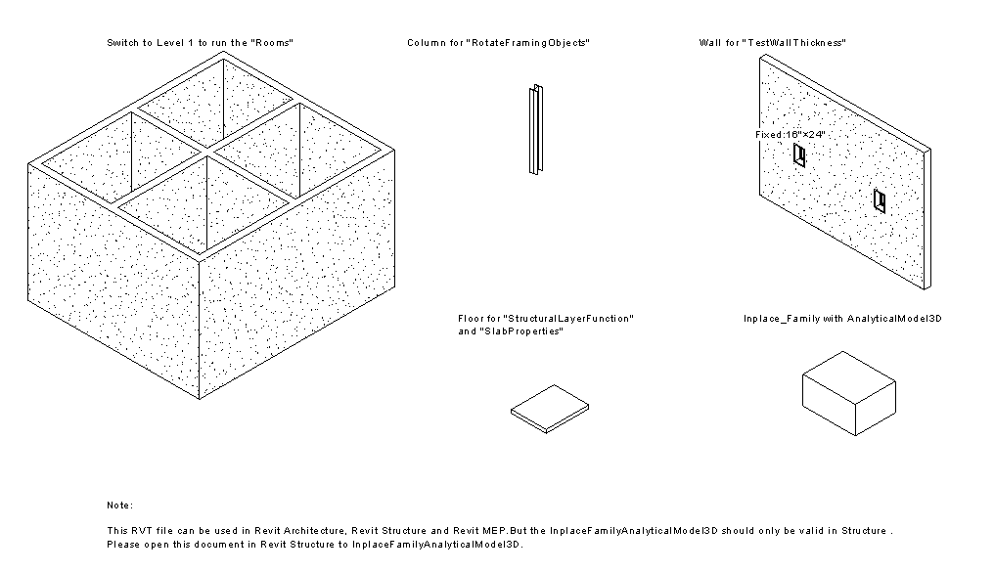
Figure 1: Revit_Macro_Samples.rvt

C# Samples:
Sample Type | Sample Macro Name | Notes
Simple Samples | QuickPrint_FloorPlans  QuickPrint_Elevations  QuickPrint_Section
Simple Samples | FindAndReplaceText
Simple Samples | CapitalizeText
Simple Samples | FindAndReplaceWinType
Simple Samples | DeleteObject
Simple Samples | ProjectInfo
Common Samples | CreateBeamsColumnsBraces
Common Samples | GridCreation
Common Samples | InplaceFamilyAnalyticalModel3D | Revit Structure only
Common Samples | Rooms | Not available for Revit Structure
Common Samples | RotateFramingObjects
Common Samples | SlabProperties
Common Samples | StructuralLayerFunction
Table 1: Revit Macro Samples in C#
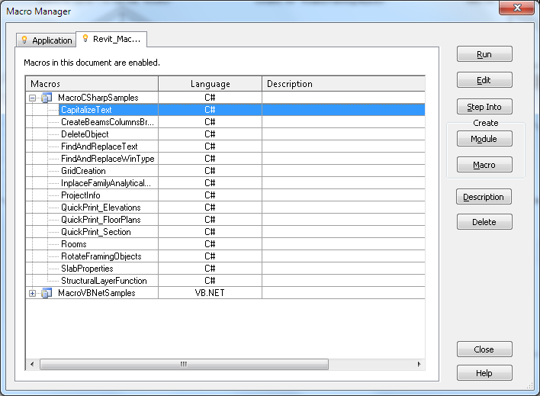
Figure 2: Revit Macro Samples in C#

1.2. VB.Net Samples:
Sample Type | Sample Macro Name | Others
Simple Samples | QuickPrint_FloorPlans  QuickPrint_Elevations  QuickPrint_Section
Simple Samples | FindAndReplaceText
Simple Samples | CapitalizeText
Simple Samples | FindAndReplaceWinType
Simple Samples | DeleteObject
Common Samples | CreateBeamsColumnsBraces
Common Samples | DesignOptionReader
Common Samples | InplaceFamilyAnalyticalModel3D | Revit Structure only
Common Samples | MaterialProperties
Common Samples | RotateFramingObjects
Common Samples | SlabProperties
Common Samples | StructuralLayerFunction
Common Samples | TestWallThickness
Table 2: Revit Macro Samples in VB.Net

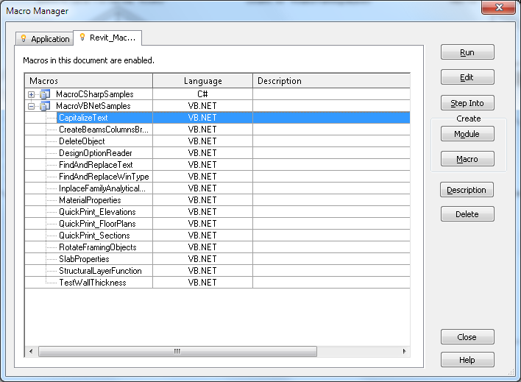
Figure 3: Revit Macro Samples in VB.Net

- Revit_Macro_MEP_Samples.rvt
Please open this file in Revit MEP. There are only two document-level macros (one C# sample macro and one VB.Net sample macro).

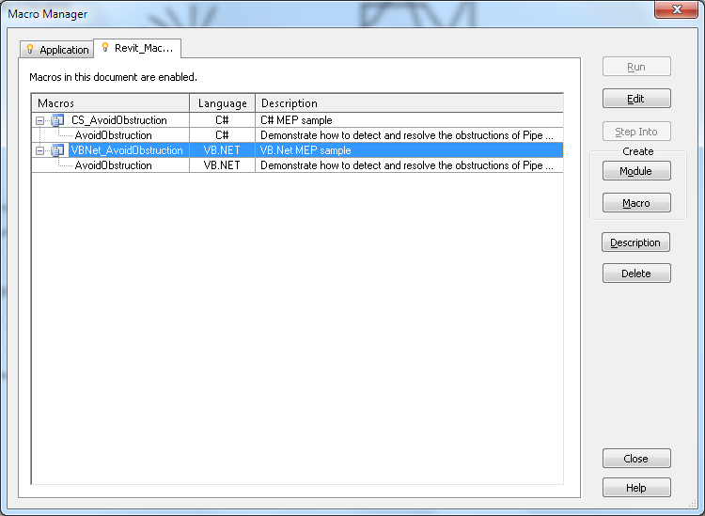
Figure 4: Revit Macro MEP Samples

- Revit_Macro_Family_Samples.rfa
Revit_Macro_Family_Samples.rvt can be opened by Revit Architecture, Revit Structure and Revit MEP. There are several document-level family samples included (5 C# sample macros and 5 VB.Net sample macros).
Sample Type | Sample Macro Name | Others
Family Samples | AutoJoin
Family Samples | AutoParameter
Family Samples | GenericModelCreation
Family Samples | TypeRegeneration
Family Samples | ValidateParameters
Table 3: Revit Macro Family Samples

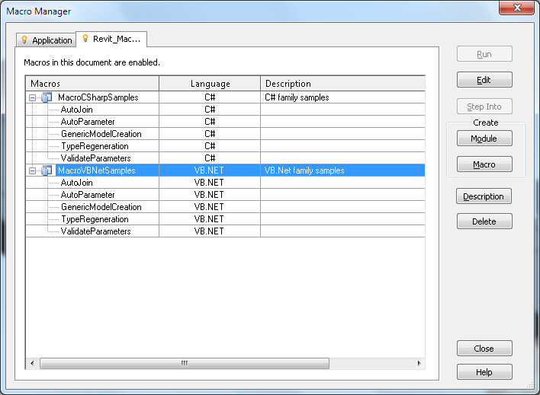
Figure 5: Revit Macro Family Samples

Folder “GetTimeElapsed_CSharp”
This is a C# application-level module; it contains a macro named “GetTimeElapsedSinceLastSave. This sample demonstrates a possible situation of application-level macros to monitor the Revit session for certain events, such as document saving.

Please copy this folder into

%ALLUSERSPROFILE%\Autodesk\Revit\Macros\2015\
[Architecture|MEP|Structure|Revit]\AppHookup

And then run it in macro manager dialog box.

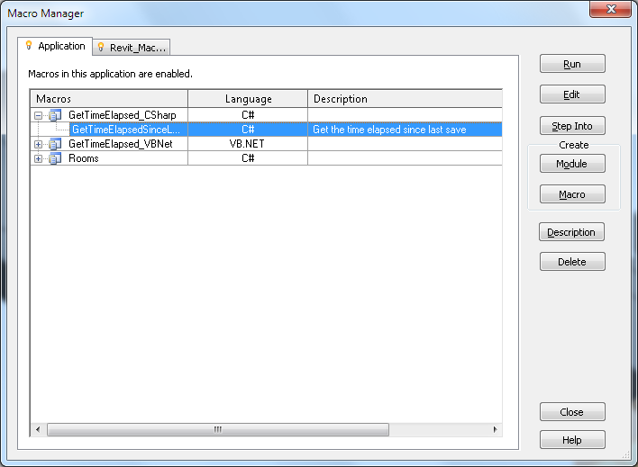
Figure 6: Application-level macro "GetTimeElapsedSinceLastSave" in C#

Folder “GetTimeElapsed_VBNet”
This is a VB.Net application-level module, please see the description above.

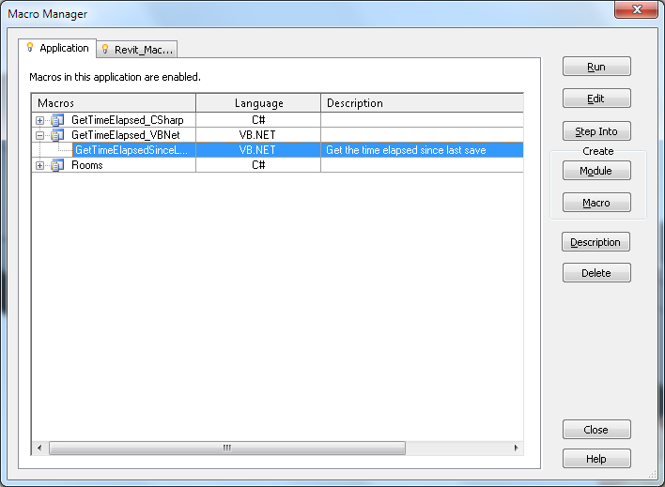
Figure 7: Application-level macro "GetTimeElapsedSinceLastSave" in VB.Net

Folder “Rooms”
This is a C# application-level module. It includes application-level “GetAllRoomsInformation” macro. You can copy this folder into

%ALLUSERSPROFILE%\Autodesk\Revit\Macros\2015\
[Architecture|MEP|Structure|Revit]\AppHookup

And then run it in macro manager dialog box.

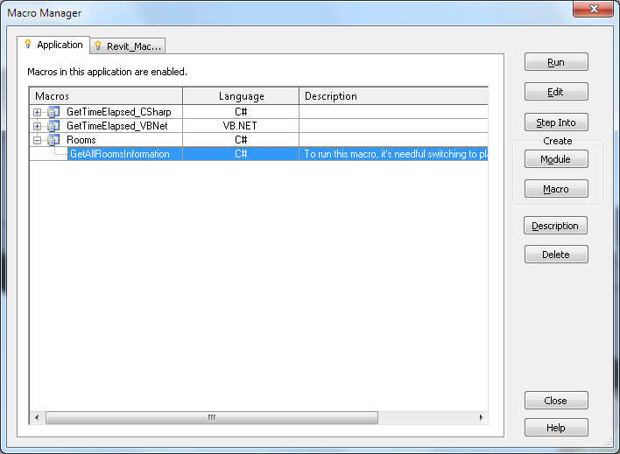
Figure 8: Application-level macro "Rooms" in C#
Note: A document-level version of the “Rooms” macro is contained in Revit_Macro_Samples.rvt.

